______________________________________________

Ex. No: 1
Date: Find the Web site address using Socket programming
AIM:
To find the website address using socket programming
ALGORITHM:

Step 1: Start the process.
Step 2: Initialize the file stream and find the size of file using available()method.
Step 3: Read a character from the file and print it using Print stream object
Step 4: using Inet address to find the host ip address
Step 5: Close print stream
Step 6: Stop the process

import java.net.*;
import java.util.*;
public class IPFinder
{
public static void main(String[] args)
{
String host;
Scanner input = new Scanner(System.in);
System.out.print("\n\nEnter host name: ");
host = input.next();
try
{
InetAddress address = InetAddress.getByName(host);
System.out.println("IP address: " + address.toString());
}
catch (UnknownHostException uhEx)
{
System.out.println("Could not find " + host);
}
}
}

Out put
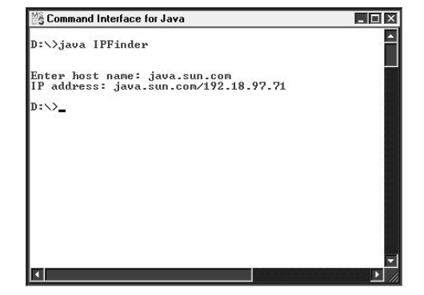

______________________________________________

Ex. No: 2
Date: Find the local host IP address using Socket programming

AIM:
To find the local host IP address using socket programming
ALGORITHM:
Step 1: Start the process.
Step 2: Initialize the file stream and find the size of file using available()method.
Step 3: Read a character from the file and print it using Print stream object
Step 4: using Inet address to find the host ip address
Step 5: Close print stream
Step 6: Stop the process

import java.net.*;
public class MyLocalIPAddress
{
public static void main(String[] args)
{
try
{
InetAddress address =InetAddress.getLocalHost();
System.out.println(address);
}
catch (UnknownHostException uhEx)
{
System.out.println("Could not find local address!");
}
}
}

Output
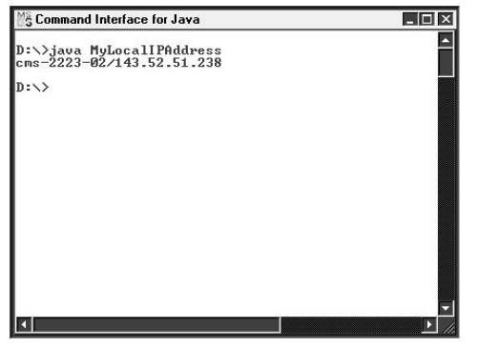

____________________________________________

Ex. No: 3
Date: SOCKET PROGRAMMING USING UDP
AIM:
To transfer a file from the client to server using TCP/IP Protocol.
ALGORITHM:
CLIENT SIDE
Step 1: Start the process.
Step 2: Initialize the file stream and find the size of file using available()method.
Step 3: Initialize the socket with the Port ID
Step 4: Read a character from the file and print it using Print stream object
Step 5: Close print stream
Step 6: Stop the process
SERVER SIDE
Step 1: Start the process.
Step 2: Import the net package. Initialize a file pointer and buffered writer object.
Step 3: Initialize the server socket with the Port ID as given in the client
Step 4: Initialize the server socket to accept the data send by the clients.
Step 5: Initialize the buffered reader object
Step 6: Write the data received in to the file until null character is reached
Step 7: Close the File and Socket Objects
Step 8: Stop the process

CLIENT PROGRAM:
import java.net.*;
import java.io.*;

class DatagramClient
{
public static DatagramSocket ds;
public static byte buffer[]=new byte[1024];
public static int clientport=789, serverport=790;

public static void main(String args[]) throws Exception
{
ds=new DatagramSocket(clientport);
System.out.println("Client is waiting for servder to send data");
System.out.println("Press Ctrl+C to come out");

while(true)
{
DatagramPacket dp=new DatagramPacket(buffer, buffer.length);
ds.receive(dp);
String pdata=new String(dp.getData(),0, dp.getLength());
System.out.println(pdata);
}
}
}

SERVER PROGRAM:
import java.net.*;
import java.io.*;
class DatagramServer
{
public static DatagramSocket ds;
public static int clientport=789, serverport=790;

public static void main(String args[]) throws Exception
{
byte buffer[]=new byte[1024];

ds=new DatagramSocket(serverport);
BufferedReader breader=new BufferedReader(new InputStreamReader(System.in));
System.out.println("Server is waiting for input");
while(true)
{ String str=breader.readLine();
if(str==null || str.equals("End"))
break;
buffer=str.getBytes();
ds.send(new DatagramPacket(buffer, str.length(), InetAddress.getLocalHost(),clientport));
}
}
}

OUTPUT:
SERVER SIDE:
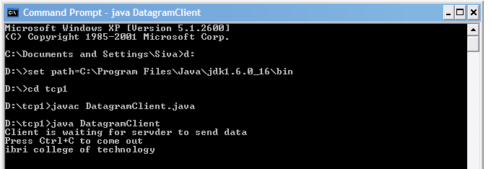

CLIENT SIDE:
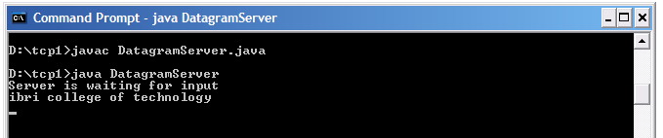
RESULT:
Thus the socket programming using UDP has been executed successfully.
_

_________________________________________

Ex. No: 4

Date: SOCKET PROGRAMMING USING TCP
____________________________________________
AIM:
To write a program to transfer string between client and server using TCP

ALGORITHM:
Step 1: Start the program
Step 2: Include the import java.net.*;
Import java.lang.*;Package
Step 3: Define a class for implementing main method.
Step 4: Port is the number that indicates what kind of protocol a server on the Internet is
using.
Step 5: A datagram socket is the sending or receiving point for a packet delivery service.
Each packet sent or received on a datagram socket is individually addressed and noted.
Step 6: Datagram packets are used to implement a connectionless packet delivery service.
Each message is routed from one machine to another based solely on information
contained within that packet.
Step 7: The string is transferred by client to server. If the server is ready it sends the
sequence of the requested string to the client.
Step 8: Print out with the necessary details.

SERVER:
import java.io.*;
import java.net.*;
class tcpserver1
{
public static void main(String args[])throws IOException
{
ServerSocket ss=new ServerSocket(55);
Socket s=ss.accept();
DataInputStream in=new DataInputStream(s.getInputStream());
DataOutputStream out=new DataOutputStream(s.getOutputStream());
DataInputStream sysin=new DataInputStream(System.in);
System.out.println("Enter an string:");
String str=sysin.readLine();
out.writeBytes(str+"\n");
System.out.println("The string from TcP server"+in.readLine());
}
}

CLIENT
import java.net.*;
import java.io.*;
public class tCPclient1
{
public static void main(String args[])throws IOException
{
Socket s=new Socket("localhost",55);
DataInputStream in=new DataInputStream(s.getInputStream());
DataOutputStream out=new DataOutputStream(s.getOutputStream());
String str=in.readLine();
System.out.println("string from TCP server"+str);
}
}
OUTPUT:
D:\java\MEPRACTICE>java server
CRICKET WORLD CUP

D:\java\MEPRACTICE>java client
CRICKET WORLD CUP

RESULT:
Thus the socket programming using TCP has been executed successfully.

________________________________________

Ex. No: 5
Date: IMPLEMENTATION OF PING
_____________________________________________
AIM:
To implement ping command to determine the connectivity of a host in a network.
ALGORITHM:

Step 1: Create a object for runtime, process classes.

Step 2: Create an object ‘r’ for runtime.

Step 3: Get the runtime environment by calling getRuntime() method and assign it to r.

Step 4: Execute the ping command using the exec() method of Runtime class.

Step 5: Store the result in ‘p’, object of process class, if object value is null

Step 6: Create a string object to get IP address.

Step 7: If it starts with request, the n print “there is no replay and connection”

Step 6: Stop

CLIENT PROGRAM:
import java.io.*;
import java.net.*;
class pingdemo
{
public static void main(String args[])
{
BufferedReader in;
try
{
Runtime r=Runtime.getRuntime();
Process p=r.exec("Ping 127.0.0.1");

if(p==null)
System.out.println("could not connect");
in=new BufferedReader(new InputStreamReader(p.getInputStream()));
String line;

while((line=in.readLine())!=null)
{
if(line.startsWith("reply"))
System.out.println("this is reply");
else if(line.startsWith("request"))
System.out.println("there is no reply");
else if(line.startsWith("destinator"))
System.out.println("destinator host unreachabl");
else
System.out.println(line);
}
System.out.println(in.readLine());
in.close();
} catch(IOException e)
{System.out.println(e.toString());}
}
}

OUTPUT:
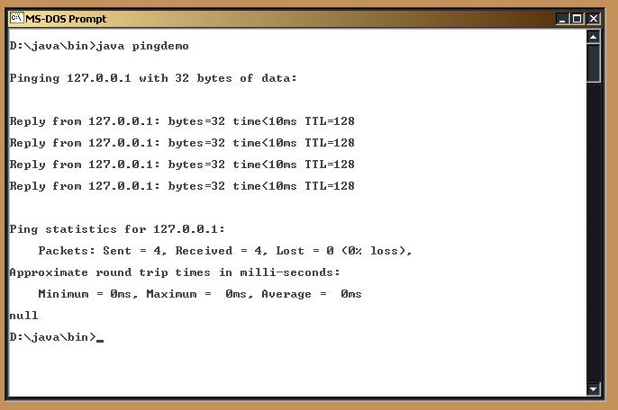

RESULT:
Thus the program for ping was implemented to check the connectivity of a host in a network.

__________________________________________

Ex. No: 6

Date: IMPLEMENTATION OF ARP
_____________________________________________
AIM:
To implement the concept of Address Resolution Protocol.
ALGORITHM:
Step 1: Start the process.
Step 2: Execute the server side program.
Step 3: Enter the MAC address of the machine.
Step 4: The IP address will be displayed.
Step 5: Execute the client side program.
Step 6: IP address will be received from server.
Step 7: Stop the process.

CLIENT SIDE:
import java.net.*;
import java.io.*;
public class arpclient
{ public static void main(String args[])throws IOException
{ Socket s=new Socket("localhost",55);
DataInputStream in=new DataInputStream(s.getInputStream());
DataOutputStream out=new DataOutputStream(s.getOutputStream());
String iparr[]={"10.0.1.45","172.16.5.21","172.16..5.22"};
String macarr[]={"00-0c-6e-5c-3c-63","02-11-B6-F3-EF-21","03-12-B3-F3-EF-18"};
String str=in.readLine();
System.out.println("Ip Address received from server"+str);
int flag=0;
for(int i=0;i<5;i++)
{
if(str.equals(iparr[i])==true)
{
flag=1;
String str1=macarr[i];
out.writeBytes(str1+"\n");
break;
}
}
if(flag==0)
System.out.println("Given IPAddress is not in the network");
s.close();
}
}
SERVER SIDE:
import java.io.*;
import java.net.*;
class arpserver
{
public static void main(String args[])throws IOException
{
ServerSocket ss=new ServerSocket(55);
Socket s=ss.accept();
DataInputStream in=new DataInputStream(s.getInputStream());
DataOutputStream out=new DataOutputStream(s.getOutputStream());
DataInputStream sysin=new DataInputStream(System.in);
System.out.println("Enter an IP Address:");
String str=sysin.readLine();
out.writeBytes(str+"\n");
System.out.println("The corresponding MAC address"+in.readLine());
}
}

OUTPUT:
SERVER
E:\ss\exno7>javac arpserver.java
E:\ss\exno7>java arpserver
Enter an IP Address:
10.0.1.45
The corresponding MAC address is:00-0c-6e-5c-3c-63
CLIENT
E:\ss\exno7>javac arpclient.java
E:\ss\exno7>java arpclient
IP Address received from server
10.0.1.45

RESULT:
Thus the program for ARP has been executed successfully.

_______________________________________

Ex. No: 7
Date: IMPLEMENATATION OF RARP
___________________________________________
AIM:
To implement the concept of R-Address Resolution Protocol.
ALGORITHM:
Step 1: Start the process.
Step 2: Execute the server side program.
Step 3: Enter the MAC address of the machine.
Step 4: The IP address will be displayed.
Step 5: Execute the client side program.
Step 6: MAC address will be received from server
Step 7: Stop the process

CLIENT
import java.net.*;
import java.io.*;
public class rarpc
{
public static void main(String args[])throws IOException
{
Socket s=new Socket("localhost",55);
DataInputStream in=new DataInputStream(s.getInputStream());
DataOutputStream out=new DataOutputStream(s.getOutputStream());
String iparr[]={"10.0.1.45","172.16.5.21","172.16..5.22"};
String macarr[]={"00-0c-6e-5c-3c-63","02-11-B6-F3-EF-21","03-12-B3-F3-EF-18"};
String str=in.readLine();
System.out.println("Ip Address received from server"+str);
int flag=0;
for(int i=0;i<5;i++)
{
if(str.equals(macarr[i])==true)
{
flag=1;
String str1=iparr[i];
out.writeBytes(str1+"\n");
break;
}
}
if(flag==0)
System.out.println("Given IPAddress is not in the network");
s.close();
}
}
SERVER
import java.io.*;
import java.net.*;
class rarps
{
public static void main(String args[])throws IOException
{
ServerSocket ss=new ServerSocket(55);
Socket s=ss.accept();
DataInputStream in=new DataInputStream(s.getInputStream());
DataOutputStream out=new DataOutputStream(s.getOutputStream());
DataInputStream sysin=new DataInputStream(System.in);
System.out.println("Enter an mac Address:");
String str=sysin.readLine();
out.writeBytes(str+"\n");
System.out.println("The corresponding MAC address"+in.readLine());
}
}

OUTPUT:
SERVER
E:\ss\exno8>javac rarps.java
E:\ss\exno8>java rarps
Enter an MAC Address:
00-0c-6e-5c-3c-63
The corresponding IP address is:10.0.1.45
CLIENT
E:\ss\exno8>javac rarpc.java
E:\ss\exno8>java rarpc
MAC address received from server00-0c-6e-5c-3c-63

RESULT:
Thus the program for R-Address Resolution Protocol has been executed successfully.

_____________________________________

Ex. No: 8

Date: IMPLEMENTATION OF FTP
_____________________________________________
AIM:
To transfer the file from server to client using FTP protocol.
ALGORITHM:
Step 1: Start the process.
Step 2: create a file named output.
Step 3: Compile and run the server program.
Step 4: “File successfully sent” message will be displayed.
Step 5: Compile and run the client program.
Step 6: “File received successfully” message along with the copy of the file will be displayed.
Step 7: Stop the Process.

CLIENT PROGRAM:
import java.io.*;
import java.net.*;
public class Ftpclient
{
public static void main(String a[])throws IOException
{
Socket s=new Socket(InetAddress.getLocalHost(),5555);
DataInputStream s1=new DataInputStream(s.getInputStream());
DataInputStream inp=new DataInputStream(System.in);
DataOutputStream so=new DataOutputStream(s.getOutputStream());
System.out.println("\n enter the filename(path)");
String str=inp.readLine();
so.writeBytes(str);
so.writeBytes("\n");
FileOutputStream fos=new FileOutputStream("output.txt");
int str1;
while((str1=s1.read())!=-1)
fos.write((char)str1);
System.out.println("\n file received successfully");
s1.close();
so.close();
inp.close();
s.close();
}
}

SERVER PROGRAM:
import java.io.*;
import java.net.*;
public class Ftpserver
{
public static void main(String a[])throws IOException
{
ServerSocket ss=new ServerSocket(5555);

Socket s=ss.accept();
DataOutputStream dos=new DataOutputStream(s.getOutputStream());
DataInputStream din=new DataInputStream(s.getInputStream());
String s1;
s1=din.readLine();
FileInputStream fin=new FileInputStream(s1);
int str1;
while((str1=fin.read())!=-1)
dos.writeBytes(""+(char)str1);
System.out.println("\n file successfully sent");
dos.close();
din.close();
s.close();
}
}

SERVER SIDE:
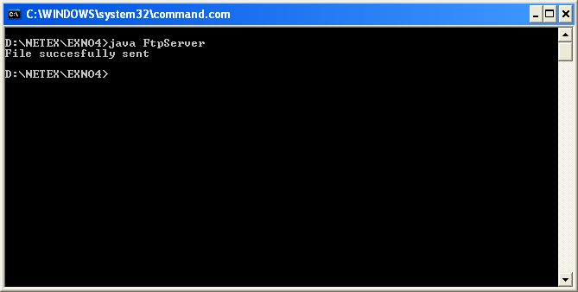
CLIENT SIDE:
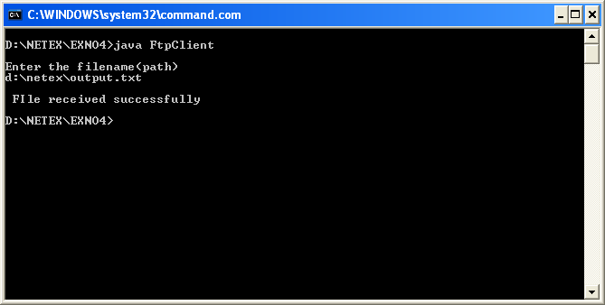
RESULT:
Thus the file transfer through FTP has been executed successfully.

___________________________________________

Ex. No: 9

Date: IMPLEMENTATION OF REMOTE COMMAND EXECUTION
_____________________________________________
AIM:
To create a java program to implement the remote command execution.
ALGORITHM:
CLIENT SIDE
Step 1: Start the process.
Step 2: Connect the server host.
Step 3: Get the input
Step 4: Write the input to the output stream.
Step 5: Send the input to the server.
Step 6: Stop the process
SERVER SIDE
Step 1: Start the process.
Step 2: Connect to the client.
Step 3: Check whether the connection is accepted.
Step 4: Receive the input sent by the client.
Step 5: Print the data.
Step 6: Close the connection.
Step 7: Stop the process.

CLIENT SIDE
import java.net.*;
import java.io.*;
public class rmc
{ public static void main(String args[])
{ try
{
FileInputStream f=new FileInputStream("a.txt");
int si=f.available();
System.out.println("Size-----"+si);
System.out.println("contents in the file");
Socket s=new Socket("localhost",1500);
PrintStream p=new PrintStream(s.getOutputStream());
for(int i=0;i<si;i++)
{
char r=(char)f.read();
p.print(r);
System.out.print(r);
}
p.close();
s.close();
}
catch(Exception e)
{ System.out.print(e);
}
}
}
SERVER SIDE:
import java.net.*;
import java.io.*;
public class rms
{ public static void main(String args[])
{ int port=1500;
ServerSocket server_socket;
BufferedReader input;
try{
server_socket=new ServerSocket(port);
System.out.println("Server waiting for client on port"+server_socket.getLocalPort());
while(true)
{
Socket socket=server_socket.accept();
System.out.println("New connection accepted"+socket.getInetAddress()+":"+socket.getPort());
input=new BufferedReader(new InputStreamReader(socket.getInputStream()));
while(true)
{
String message=input.readLine();
Runtime r=Runtime.getRuntime();
Process p=r.exec(message);
}
}
}
catch(Exception e)
{ System.out.println(e);
}
}
}

OUTPUT:
CLIENT
E:\ss\exno6>javac rmc.java
E:\ss\exno6>java rmc
NotePad
SERVER
E:\ss\exno6>javac rms.java
E:\ss\exno6>java rms
Notepad

RESULT:
Thus the program for remote command execution has been executed successfully. _____________________________

_________________________________________

Ex. No: 10
Date DISPLAY THE MESSAGE FROM CLIENT TO SERVER USING UDP

AIM:
To write a program to transfer string between client and server using UDP.

ALGORITHM:
Step 1: Start the program
Step 2: Include the import java.net.*;
Import java.lang.*;Package
Step 3: Define a class for implementing main method.
Step 4: Port is the number that indicates what kind of protocol a server on the Internet is
using.
Step 5: A datagram socket is the sending or receiving point for a packet delivery service.
Each packet sent or received on a datagram socket is individually addressed and noted.
Step 6: Datagram packets are used to implement a connectionless packet delivery service.
Each message is routed from one machine to another based solely on information
contained within that packet.
Step 7: The string is transferred by client to server. If the server is ready it sends the
sequence of the requested string to the client.
Step 8: Print out with the necessary details.

SERVER:
import java.io.*;
import java.net.* ;
import java.lang.*;
public class udpserver
{
public static int serverport=998;
public static int clientport=999;
public static int buffersize=1024;
public static byte buffer[]=new byte[buffersize];
public static DatagramSocket ds;
public static void serve() throws Exception
{ int pos=0;
System.out.println(" I AM WAITING FOE YOUR INPUT");
while(true)
{ int c = System.in.read();
switch(c)
{
case 1:
System.out.println("server");
return;
case '\r':break;
case '\n':ds.send(new DatagramPacket(buffer,pos,InetAddress.getLocalHost(),clientport));
pos=0;
break;
default:
buffer[pos++]=(byte)c;
break;
}
}
}
public static void main(String arg[])throws Exception
{ ds=new DatagramSocket();
serve();
}
}

CLIENT
import java.net.*;
class udpclient
{
public static int serverport=998;
public static int clientport=999;
public static int buffersize=1024;
public static byte buffer[]=new byte[buffersize];
public static DatagramSocket ds;
public static void serve() throws Exception
{
while(true)
{ DatagramPacket p = new DatagramPacket(buffer, buffer.length);
ds.receive(p);
System.out.println(new String(p.getData(),0,p.getLength()));
}
}
public static void main(String arg[])throws Exception
{
ds = new DatagramSocket(clientport);
serve();
}
}

OUTPUT:
D:\java\MEPRACTICE>java server
I AM WAITING FOR YOUR INPUT
Ibri college of technology

D:\java\MEPRACTICE>java client
Ibri college of technology

